Problem set 2 BB2920 – Genetics - C term 2014 due **in class** Fri 1/31/14

Question 1, 30 points

Phenylketonuria (PKU) is a metabolic disorder in which patients lack expression of an enzyme called phenylalanine hydroxylase (PAH), which breaks down phenylalanine from the foods we eat into tyrosine. In the absence of PAH function, phenylalanine builds up to extremely high concentrations and causes brain damage and mental retardation. The six people below were tested for PKU. Person A is an unaffected control. Person B is not affected, but has affected children. Persons C, D, E and F all have PKU. DNA (digested with HindIII), mRNA and protein samples were collected from each person and were analyzed. The results are below.

1. With reference to the Southern, Northern, and Western blots below, explain what the likely mutation is that affects persons C, D, E and F. (Remember, C, D, E and F are all AFFECTED by the disease, which means they ALL have a hypomorphic or amorphic mutation in the PKU gene. I am looking for insights about the type of molecular mutation - insertion, deletion, base change, missense, nonsense, etc). Note: you must mention the results on *each* blot for *each* person to get full credit.
2. Why is person B unaffected? Note the differences on the Northern and Western blots between person A and person B in your response.
3. One of the affected patients (C, D, E, or F) is the child of person B. Which one? Explain how you can make this decision based on the blots.

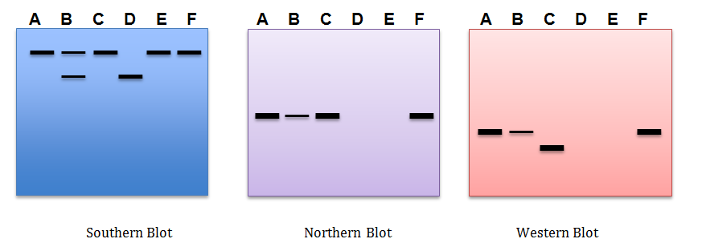

**Part (a) – 5 points per response. Half credit (2.5 points) can be awarded at the PLA’s discretion for partially correct responses. Full credit responses should address the status of the DNA, RNA and protein shown on the blots for EACH person, as well as identify the correct type of mutation.**

**Person C has a normal sized gene on the Southern blot that transcribes a normal-sized RNA on the Northern blot, but protein that is detected on the Western blot is smaller than normal. It is likely that this person has a nonsense (stop codon) mutation somewhere in the middle of the coding region that results in the production of a shortened, non-functional protein. Note: a small frameshift insertion/deletion could also potentially give these results if the frame shift creates a stop codon close to the site of the mutation. If they explain this scenario correctly award full credit**

**Person D has a smaller, mutant version of the gene, as determined on the Southern blot. This mutation is likely a deletion, because the gene is smaller. No RNA is transcribed because none is detected on the Northern blot. That means the deletion includes the promoter region for the gene. No RNA means no protein can be translated and no signal seen on the Western blot.**

**Person E has a normal sized gene on the Northern, but it does not transcribe RNA or make protein. This person likely has a mutation that prevents transcription of the gene, such as a base change mutation in the promoter region that makes it unrecognizable to RNA polII.**

**Person F has a normal sized gene, transcribes normal sized RNA, and translates normal sized protein. However, this person is still affected by the disease, as stated in the question. Therefore the protein that is made is not functional. This person likely has a missense mutation encoding a key amino acid that prevents the normal function of the protein.**

**(b) Person B is not affected because he is heterozygous for the mutant gene. That is, he has one normal gene copy and one mutant copy. The one normal copy doesn’t make quite as much PAH as two normal copies would - that’s why northern blot shows less RNA than person A, and western blot shows less protein than person A- but makes enough PAH to convert phenylalanine to tyrosine, so person B is phenotypically normal. [5 points, no partial credit, key info is that people have two copies of every gene, and in this case one copy has a deletion (they do not specifically have to use the word “heterozygote”)]**

**(c) Person D is likely the child of person B. Person D and person B both have regions of their DNA that look smaller than normal on a Southern blot, which indicates they both have a chromosome containing a deletion. Person B must have passed on the chromosome to his/her child that contained the deletion, and the child also inherited a copy of the deletion from the other parent. [5 points no partial credit, key info is that person B and person D have the same deletion mutation as determined on the Southern, so person D likely inherited the deletion from person B]**

Question 2, 20 points

EcoRI is a restriction enzyme that recognizes the sequence GAATTC. Briefly define each type of mutation listed below, and describe what would happen to the function of EcoRI if it obtained each mutation. Make reference to the specific function of EcoRI (eg, it binds to GAATTC and cuts it) in your response.

**4 points each: 2 points for an accurate definition, 2 points for an example related to EcoRI function that makes sense. It doesn’t have to be the EXACT example as given below, but it must make sense with the correct definition of each mutation type.**

1. hypermorph – **This mutation causes protein to have the same function, but increased activity, so EcoRI still cuts GAATTC, but does so at a faster rate**
2. amorph – **This mutation results in no activity. So the EcoRI is completely non-functional, either cannot recognize GAATTC or can recognize it but cannot cut it**
3. neomorph – **This mutation causes a new function that the protein didn’t have before, so maybe it starts recognizing and cutting other sites, like GGATCC. Typically a neomorph has a function related to the original function, but technically it is possible it takes on a completely unrelated function, like it all the sudden starts ligating the ends of RNA molecules together.**
4. hypomorph – **This mutation causes** **the ligase works at a decreased speed. EcoRI would still bind and cut GAATTC, but it would do it more slowly.**
5. antimorph – **This type of mutation results in an opposite function from the original function. So for a restriction enzyme like EcoRI, this might mean it starts joining free ends of DNA instead of cutting the DNA.**

Question 3, 20 points

You have a plasmid vector that contains this restriction site: 5’A/GATCT3’ (slash indicates the cut site). You are attempting to clone an ~1kb DNA fragment containing the following restriction site on both ends: 5’G/GATCC3’.

(a) If you cut each of these sequences with the appropriate enzymes, can you ligate the DNA fragment into this plasmid? Why or why not?

**5 points, no partial credit Yes, these will ligate, because they have complementary sticky ends. (the GATC sequence will anneal)**

(b) Draw a schematic of the plasmid and the insert *before* and *after* cloning to illustrate your answer to part A.

**10 points, see correct diagrams below. Must show both DNA strands (the figure doesn’t work without it) and the restriction enzyme sites must be in the correct orientation. Make sure the correct restriction site is associated with the vector and the insert. Deduct half of the total (5 points) if the figures are close but not exactly right, and deduct all if there are serious flaws (eg only one strand shown, cut sites in the complete wrong place, etc). This is at the discretion of the graders, no other partial credit awarded.**

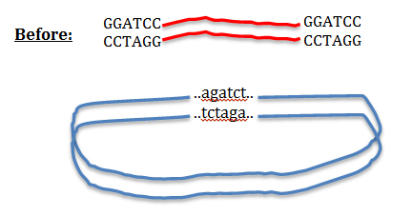

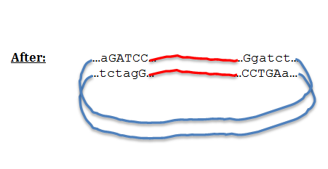

c) Can the resulting plasmid be re-cut with either enzyme in the future? Why or why not?

**no, because the resulting sequences (5’ggatct3’ and 5’agatcc3’) are not palindromes and will no longer be recognized as restriction sites. [5 points, no partial credit, they do not have to use the word “palindrome” but should acknowledge that the sequences are no longer correct for identification by the enzymes.]**

Question 4, 30 points

You are a molecular geneticist working for a major drug company. This drug company has discovered a strain of yeast that produces a new and highly potent inhibitor of cholesterol absorption from the intestinal tract. The drug company sees this as an important (and potentially very lucrative) therapy for hypercholesterolemia, or high cholesterol, which affects millions of people. The company has named the inhibitor molecule CholeBlock.

The yeast turns a precursor metabolite into CholeBlock using an enzyme called Yfe1 (a protein product of the YFE1 gene). The simplified reaction mechanism is shown below:

Yfe1

Precursor CholeBlock

You have been given the task of tweaking the function of Yfe1 in an attempt to optimize yield of the drug. You make a number of point mutations in the gene, and then test the enzymatic function of the resulting yfe1 mutants by seeing how efficiently the mutant enzyme can convert the precursor to CholeBlock.

a) [12 points] Below are four mRNA sequences from a section of the coding region of the YFE1 mRNA, one wild type as well as three mutations you created. Translate each mRNA, and identify the type of mutation (frameshift insertion/deletion, missense conservative/non-conservative, nonsense, etc) that resulted in each case.

Wild type YFE1: 5’-AUGUACCGGCCUACCCAUCGAUACUCCGAAUUU-3’ MYRPTHRYSEF

yfe1 mutant 1: 5’- AUGUACCGGCCUACCCAUGGAUACUCCGAAUUU -3’ MYRPTHGYSEF this is a non-conservative missense mutation (R to G)

yfe1 mutant 2: 5’-AUGUACGGCCUACCCAUCGAUACUCCGAAUUU-3’ MYGLPIDTPN this is a deletion frameshift

yfe1 mutant 3: 5’- AUGUACCGGCCUACCCGUCGAUACUCCGAAUUU -3’ MYRPTRRYSEF, this is a conservative missense mutation (H to R).

these are straight translations, so no partial credit for incorrect translations. 12 total points, 3 per translation (1 point for correct translation, and 2 for identifying the correct mutation).

b) [15 points] Next, you test the wild type and the three mutants in an assay to detect the efficiency of the Yfe1 enzyme. You add the purified Yfe1 enzyme and the precursor metabolite to a test tube, and you monitor the formation of CholeBlock over time. The result of your experiment is shown below:

Describe the functional effect of each mutation (hint, I’m looking for the “-morph” description here). Based on the mutation types identified in part a, write a sentence or two about what you think happened to each enzyme (you will need to hypothesize a bit here. What I am really asking you to do is relate the physical mutation from part a to the functional mutation in part b).

15 points total; 5 points per mutant. 3 points for correct identification of the functional mutation (no partial credit). 2 points for the explanation of how the physical mutation relates to the functional mutation (be generous here, as these are hypotheses and there may be other plausible options).

Mutant 1: mutant 1 is a hypomorph. This mutation was a non-conservative missense mutation, so probably the arginine residue that was changed for the glycine was really important for the enzymatic function of Yfe1. Without that arginine, the enzyme works very slowly.

Mutant 2: mutant 2 is an amorph, or null mutant. It has no function at all. This was the mutant with the frameshift mutation. This protein is no longer the same protein that should be encoded by Yfe1, so it has no enzymatic activity.

Mutant 3: mutant 3 is a hypermorph. This mutation was a conservative missense mutation, which resulted in changing a histidine to an arginine. This enzyme now has two arginines in a row, and this seems to improve its enzymatic activity.

c) [3 points] Did you succeed in your task? Which enzyme will you present to the CEO as your “new and improved” Yfe1 at your next meeting?

Yes you succeeded, mutant 3 has increased efficiency in converting the precursor to CholeBlock, as compared to the wild type. [no partial credit, this is rather obvious]